

**Games shop**

**Software Requirement Specification**

–Hanoi, April 2022 –

* Record of changeS

|  |  |  |  |
| --- | --- | --- | --- |
| Date | A*, M, D | In charge | Change Description |
| 14/4/2022 | A | Sơn | Add context diagram and screen flow |
| 14/4 | A | HungTH | Add mockup and description |
|  |  |  |  |
|  |  |  |  |
|  |  |  |  |
|  |  |  |  |
|  |  |  |  |
|  |  |  |  |
|  |  |  |  |
|  |  |  |  |
|  |  |  |  |
|  |  |  |  |
|  |  |  |  |

*A - Added M - Modified D - Deleted

**Table of Contents**

I. Overview 4

* 1. Introduction 4
* 2. System Functions 5
* II. Functional Requirements 7
* 1. <<Feature Name 1>> 7
* a. <<Function Name 1>> 7
* b. <<Function Name 2>> 7
* 2. <<Feature Name 2>> 7

|  |  |
| --- | --- |
| Actor | Description |
| Users | Everyone view and use website |
| ~~Staff~~ | ~~Staff is summary of all user who can control website system~~ |
| Admin | Highest roll can control account, product and blog |
| Marketing | This roll can write, edit blog and answer FQAs question |
| Seller | This roll can control product like add product change/edit product and accept or reject order of customers |
| Customers | This user can buy and give feedback on product |

# Overview

Games Shop was built to help Organizations and many Professionals create and sell their online entertainment genres, and customers can play games with accounts with discounted prices and bundled promotions. , the document that accompanies them when they purchase a game account distributed by the manufacturer.

The main advantage of this system is that customers can buy anytime, anywhere using a variety of devices such as smartphones, tablets and computers. This can be an alternative form for customers (Especially students) to be able to play hot games in foreign countries that require a separate account and pay fees.

Devine Shop gives you quick and safe access to local and international video games.

## Introduction

* This website is about a game online selling codes, credits.

## System Functions

#### Screen Flow

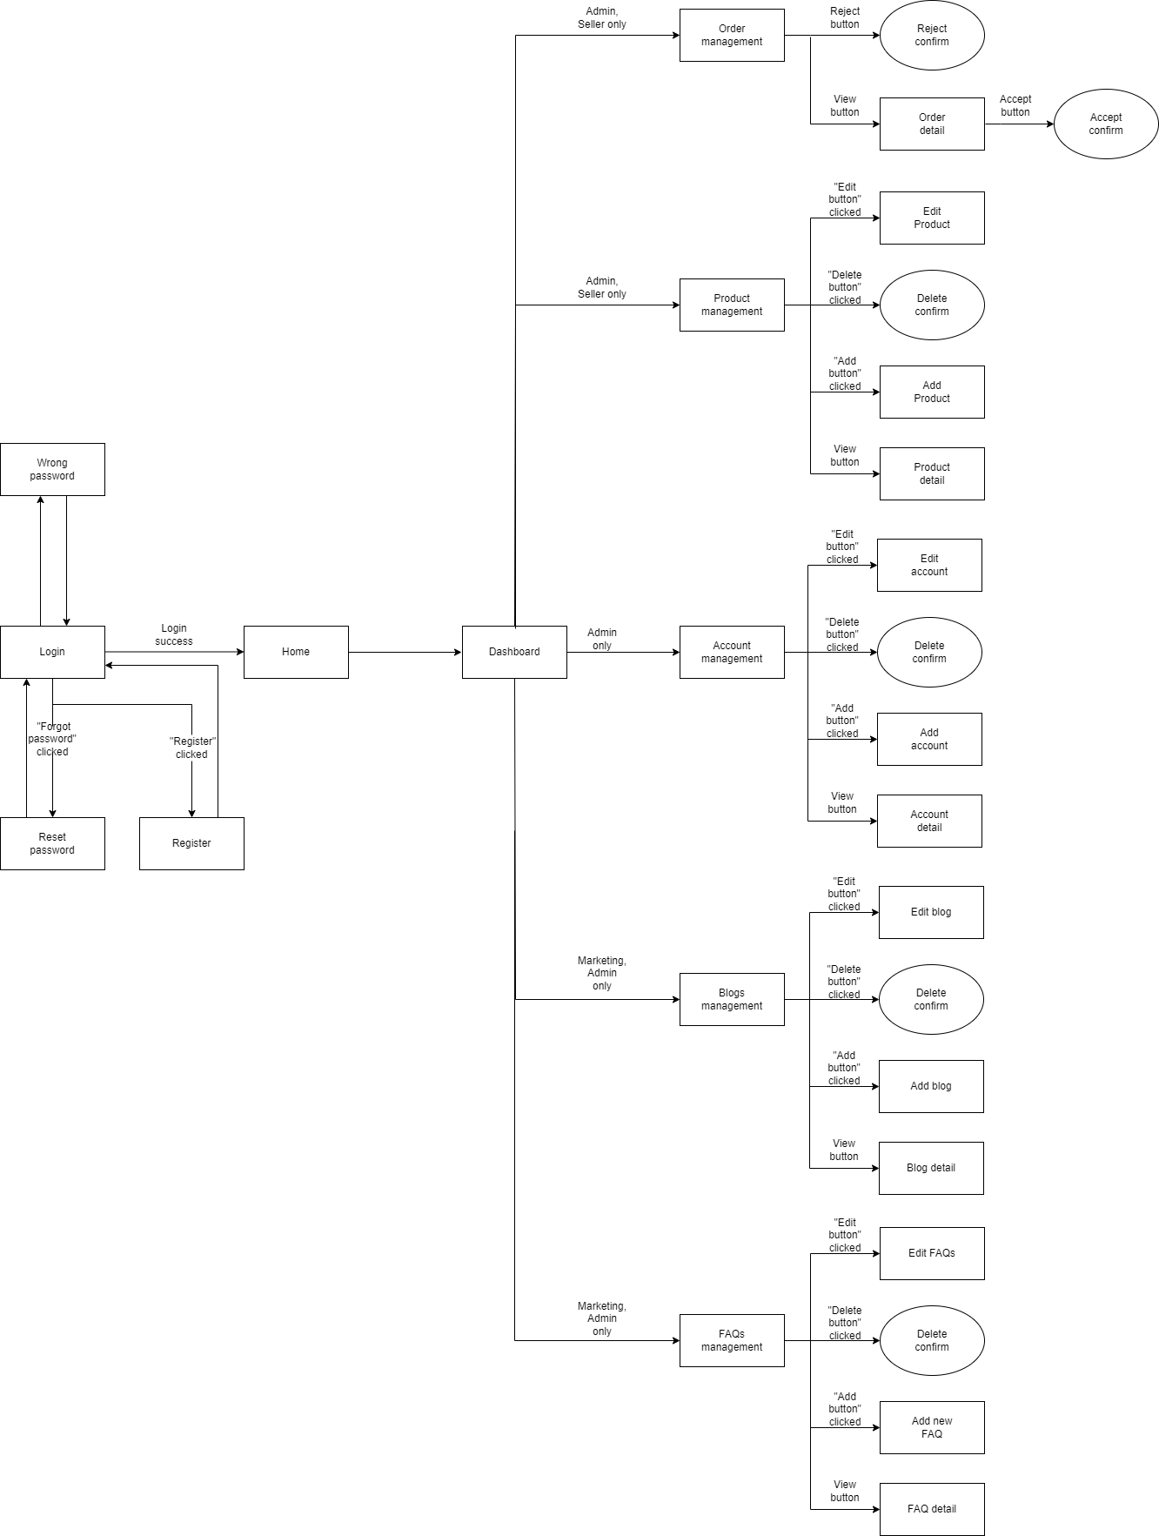

Staff screen flow

#### 



Customers screen flow

#### Screen Details

* **Screen Details**

|  |  |  |  |
| --- | --- | --- | --- |
| * **No** | **Function/Screen** | **Feature** | **Function/Screen Details** |
| 1 | User Login | Common | This is a screen which allows the user to enter email & password to login; on this page, there are also options for user to register new information or reset the password |
| 2 | User Register | Common | This is a screen which allows user register new account by input following information: full name, gender, email, mobile; User need to verify by clicking the link sent via email before login into system |
| 3 | Reset Password | Common | This is a screen which allows user find account they forgot thought email register. User input email and click in reset password they will receive a mail contain reset password link.  This link will redirect user to password reset form allow user can change password of these own account without old password. |
| 4 | Wrong password | Common | This is a screen will show message when user input wrong information of login account (password or email)  This screen will auto redirect back in login page |
| ~~5~~ | ~~User Authorization~~ | ~~Common~~ | ~~Implementation of authorization mechanism in the system, including the specify the role of logged-in user, his/her authorized page links (building the displayed menu items (in the front end) and preventing unauthorized access via enter the links directly)~~ |
| 6 | Profile detail | Common | This is a screen which allows user to view their own profile information, including all personal information & avatar image.  User can change profile detail by click in edit button to redirect in edit profile screen.  User can view order history by click in order history button |
| 7 | Order history | Common | This screen show information of all game their buy in history(OrderID , Productname, price, date,status) |
| 8 | Edit profile | Common | This is a screen which allows user to edit their own profile information, including all personal information & avatar image.  Note user not allowed to change email |
| 9 | Change Password | Common | This is a screen allows the user to change their password by input current password to verifies |
| 10 | HomePage | Common | Show sliders, hot posts, featured subjects + the sider with the latest posts, static contacts/links  Shown slider information includes its image and title; the user is redirected to the slider's backlink on their clicking  Show post information includes its thumbnail, title, post date; the user is redirected to the post's details on his/her clicking  Show subject information includes its thumbnail, title, tag line; the user is redirected to the subject's details on their clicking |
| 11 | Dashboard | Admin, seller, marketing | This screen for staff only  It give all staff member abilities to change information in system depend on their roll |
| 12 | ~~Cart~~ | ~~Common~~ | ~~All product user put to cart prepare to payment~~  ~~After check all information correct user can checkout~~ |
| 13 | Checkout | Common | This screen will show all information of your order (OrderID , ProductName, User information, price, date)  After check all information is correct click in payment button to view payment screen |
| 14 | Payment information | Common | This screen will guide users how to payment their order will full information of bank account , content transfer, price user need to pay |
| 15 | Post List | Common | Show blog list with the post search box, posts categories, latest posts, static contacts/links; Show post information includes its thumbnail, title, category, brief-info; the user is redirected to the post's details on their clicking |
| 16 | Post Details | Common | Show details (including title, author, updated date, category, and post details) of blog user choose in blogs list |
| 17 | Product | Common | Show list product the right side with the post search box, product categories, eight featured products (thumbnail, title, price); Product information includes its thumbnail, title, category, brief-info; the user is redirected to the Product Details page on his/her clicking on a product, redirected to this Product List page if the user clicks on a product category |
| 18 | Product Detail | Common | Show details (including name, thumbnail, brief info, lowest price plan option (original price, discount price), product description and Buy button) of product user choose in product list  User can increase or decrease the number of products added to the cart  After choose right amount of product user can click in add to cart button to put product in cart to buy it later |
| 19 | About Us | Common | This is a screen allow user contact to admin by input following information: full name, user title (Mr, Mrs, Ms,..), email, mobile, address; |
| ~~20~~ | ~~View history cart~~ | ~~Common~~ | ~~Show cart user history with information including total price, purchase date, status, brief information(note); user is redirected to Payment Details page when they click view details, redirected to this Payment Detais page if user clicks on See more button~~ |
| 21 | Product Management | Admin | Admin can see all product list with information(id, name, thumbnail, original price, sale price, category, status, description).  Admin can filter the products by status  Allow the admin to search products by name  Admin can choose view product their choose  Admin can add new product in to product list  Show detail product information (id, name, thumbnail, original price, sale price, category, status, description)  The admin can edit/update the information of the product |
| 22 | Order Management | Admin | Admin can see all order list by pagination with information (id, Total Price, date, note).  admin can filter the orders by status  Allow admin to search orders by name  From each order, admin can choose to view detail  Show detail order with information(id, Total Price ,date , note) can view, edit/update the information of the order |
| 23 | Notification Management | Admin | Admin can see all notification list by pagination with information(id, UserID, OrderID, Content, status, time).  The admin can filter the notifications by status  Allow the admin to search notifications by name  Show detailed notification information(id, UserID, OrderID, Content, status, time), allow the admin to add new or view notification information |
| 24 | Review Management | Admin, seller | Admin can see all feedback list by pagination with information(id, UserID, ProductID, OrderID, Star, FeedbackDetail).  The admin can filter the feedback by id  Allow admin to search feedback by Username  Show detailed feedback information(id, UserID, ProductID, OrderID, Star, FeedbackDetail), from that allow the admin to view or delete feedback information |
| 25 | Cart Details | Common | User can see all cart list by pagination with information(total price, purchase date, status, brief information(note)).  User can search cart information by name  Show detailed cart information(total price, purchase date, status, brief information(note)) |
| 26 | Post Management | Marketing, Admin | Admin and marketing roll can see all blog list by pagination with information(id, author, title, content, image).  Admin and marketing can filter the blogs by date and name  Admin and marketing can search blogs by name  Admin and marketing can choose blog to view detail and edit  Admin and marketing can write new blog  Show detailed blog information (id, author, title, content, image)  Admin and marketing can edit/update the information of the blog |
| 27 | FAQs management | Admin, marketing | Admin and marketing roll can see all FAQs list by pagination with information(id, author, title, content, date).  Admin and marketing can filter the FAQs by date and name  Admin and marketing can search FAQs by name  Admin and marketing can choose FAQs to view detail and edit  Admin and marketing can write new FAQs  Show detailed FAQs information (id, author, title, content, date)  Admin and marketing can edit/update the information of the FAQs |
| 28 | Users Management | Admin | Show the paginated list of users (include user id, full name, gender, email, mobile, role, status):  The admin can filter the users by role, status  Allow the admin to search users by full name, email…  From each user, the admin can choose to view or edit it  The page also have the button/link that allows the admin to add new user |
| 29 | User Details | Admin | Show detailed user information (avatar, full name, gender, email, mobile, role, address, status), from that allow the user to add new, view or edit user information  After adding, new generated login password would be email to the new user  The admin can edit/update the information of the user  Statistic amount user by status, active or inactive |

#### c. User Authorization

|  |  |  |  |  |
| --- | --- | --- | --- | --- |
| **Screen** | **Admin** | **Marketing** | **Seller** | **Customer** |
| Login | X | X | X | X |
| Home Page | X | X | X | X |
| Change Password | X | X | X | X |
| Contact Us | X | X | X | X |
| Check Out |  |  |  | X |
| Dashboard | X | X | X |  |
| Get Feed Back |  |  |  | X |
| View Feed Back | X | X | X | X |
| View Customer | X | X | X | X |
| Invalid Role | X | X | X | X |
| User Profile | X | X | X | X |
| Edit User profile |  |  |  | X |
| Account Manager | X |  |  |  |
| Manage Feedback | X |  |  |  |
| Reset Password | X | X | X | X |
| Search Account | X |  |  |  |
| Cart |  |  |  | X |
| Error | X | X | X | X |
| Finished Order |  |  |  | X |
| Add Blog | X | X |  |  |
| Manage Blog | X | X |  |  |
| List Blog | X | X | X | X |
| Detail Blog | X | X | X | X |
| Update Blog | X | X |  |  |
| Product list | X | X | X | X |
| Product Detail | X | X | X | X |
| Product Edit | X |  | X |  |
| Product Management | X |  | X |  |
| Order Dashboard | X | X |  |  |
| Order Detail list | X | X | X |  |
| View Order Detail | X | X | X | X |
| View Order History | X | X | X | X |
| FAQ |  |  |  |  |

#### Non-Screen Functions

|  |  |  |  |
| --- | --- | --- | --- |
| **#** | **Feature** | **System Function** | **Description** |
| 1 | Database access | Read and write to database | Read and write to database |
| 2 | User Authorization |  | Implementation of authorization mechanism in the system, including the specify the role of logged-in user, his/her authorized page links (building the displayed menu items (in the front end) and preventing unauthorized access via enter the links directly) |
| 3 | Send Email |  |  |
|  |  |  |  |

# II. Functional Requirements

## Login

* Graphical user interface, application

  Description automatically generated
* Function trigger: /signin
* Function description: When user visited home page and select login/register link. User will be redirected to this website and can perform login into the website
* Actor:
* Purpose:
* Data processing:

## Signup

* A screenshot of a computer

  Description automatically generated with medium confidence
* Function trigger: /signup
* Function description: When user visited home page and select login/register link. User will be redirected to this website and can perform login into the website
* Actor:
* Purpose:
* Data processing:

## Forgot password

* A screenshot of a computer

  Description automatically generated with medium confidence
* Function trigger: /signup
* Function description: When user visited home page and select login/register link. User will be redirected to this website and can perform login into the website
* Actor:
* Purpose:
* Data processing:

## Homepage

* Function trigger: When user access website
* Function description: Homepage will be the first page when people access the website
* Actor: Category
* Purpose: Display home page
* Data processing: HomeController => HomepageDAO => Database

## 3. Product

* Function trigger: When user click “Game” button.
* Function description: Product page is a page list all product (game) user can buy.
* Actor: User
* Purpose: Display Product page
* Data processing: ProductController => ProductDAO => Database

## 4. User Register

* Function trigger: : when user click the “Signup here” button in the Signin page
* Function description: register new user into the system, verified by the registered email
* Screen Layout:
* A screenshot of a computer

  Description automatically generated with medium confidence
* Function Details: This is a pop-up screen which allows the user to register himself/herself to the system by inputing following information: full name, gender, email, mobile; User then need to verify by clicking the link sent via email to him/her before being able to access the system.
* Actor: User
* Purpose: User Register Screen
* Data processing: RegisterUserController => AccountDAO => Database

## 5. User Profile

* + User profile
* A screenshot of a computer

  Description automatically generated with medium confidence
* Function trigger: User login and select Profile on General page
* Function description: When user logged in and select to view their own profile
* Actor: User
* Purpose: User Profile Page
* Data processing: ProfileController => AccountDAO => Database

## 6. User Authorization

* + User authorization
* Function trigger:
* Function description:  authorize user into the system functions based on his/her role
* Screen Layout: non screen
* Function Details: Implementation of authorization mechanism in the system, including the specify the role of logged-in user, his/her authorized page links (building the displayed menu items (in the front end) and preventing unauthorized access via enter the links directly)

## 7. Blog

* + Blog list
* Graphical user interface

  Description automatically generated
* A screenshot of a computer

  Description automatically generated with medium confidence
* Function trigger: Select Blog on nav bar
* Function description: When user want to see posts that has been posted on the website
* Actor: User
* Purpose: Display blog list
* Data processing: BlogController => BlogDAO => Database

## 8. Blog Details

* + Blog details
* A screenshot of a computer

  Description automatically generated with medium confidence
* Function trigger: When user select a blog to view details
* Function description: View a blog detail
* Actor: User
* Purpose: Display blog detail informations
* Data processing: BlogController => BlogDAO => Database

9. **Reset Password**

* Function trigger: by clicking the link “Forgot Password” in Login screen
* Function description: use in case the user forgot his/her password
* Screen Layout:

* Function Details: "The user to input his/her email to receive the reset password link. This link is sent to the user's email for his/her password resetting.

10. **Change Password**

* Function trigger: when user click button “Change Password” in User Profile
* Function description:
* Screen Layout:

* Function Details: This is a pop-up screen which allows the user to change his/her password by inputting his current password as well as new password (twice)

<sửa nhập pw 2 lần)

11. **Dashboard**

* Function trigger: by clicking Dashboard on Homepage
* Function description: This is for the Admin, Sale or Marketing to see and lookup for the relevant management statistics in the system, with the relevant links to the related screens.
* Screen Layout:

* Function Details: Show statistics of order (new, all), new products (amount, price, status), revenues (total, by product categories), customers (newly registered, newly bought), and the trend of order counts (success, all) by day for the last 7 days (the start date & end date can be adjustable)

**12. Cart**

* Function trigger: After login, when user click on Cart on nav bar.
* Function description:
* Screen Layout

* Function Details: Cart page will list all products user was Add to cart at Product page